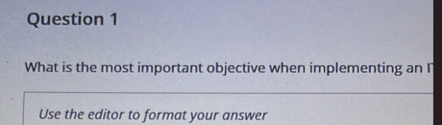

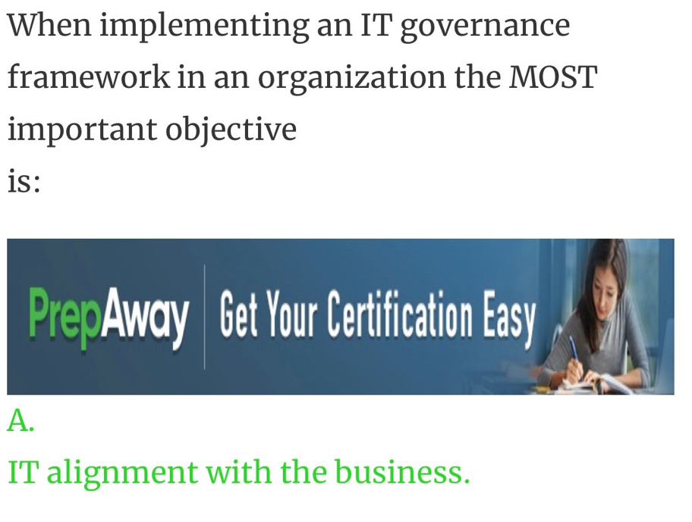

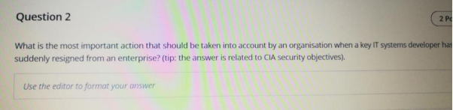

Terminate the developer's logical access to IT resources. To protect IT assets, terminating logical access to IT resources is the first and most important action to take after management has confirmed the employee's clear intention to leave the enterprise.

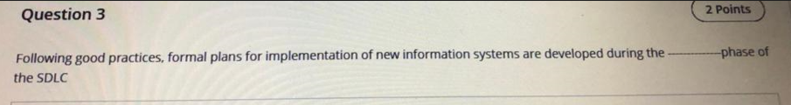

Design phase Planning for implementation should begin well in advance of the actual implementation date. A formal implementation plan should be constructed in the design phase and revised as the development progresses.

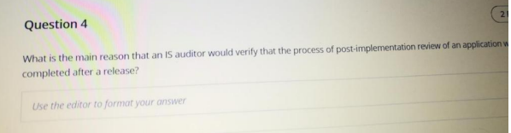

A Post-Implementation Review (PIR) is conducted after completing a project. Its purpose is to evaluate whether project objectives were met, to determine how effectively the project was run, to learn lessons for the future, and to ensure that the organization gets the greatest possible benefit from the project.

Post-implementation reviews are typically conducted after the project has been in use long enough to realize its business benefits and costs and to measure the project’s overall success and impact on the business units.

Metrics include:

Total cost of ownership (TCO)

Return on investment (ROI)

During the post-implementation review, the IS auditor should perform the following:

• Determine if the system’s objectives and requirements were achieved.

• Determine if the cost benefits are being measured, analyzed and accurately reported to

management.

• Review controls to ensure that they are operating according to design.

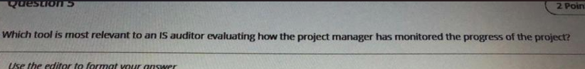

Earned value analysis

Earned value analysis (EVA) is an industry standard method for measuring a project's progress at any given point in time, forecasting its completion date and final cost, and analyzing variances in the schedule and budget as the project proceeds. It compares the planned amount of work with what has actually been completed to determine if the cost, schedule and work accomplished are progressing in accordance with the plan. EVA works most effectively if a well-formed work breakdown structure exists.

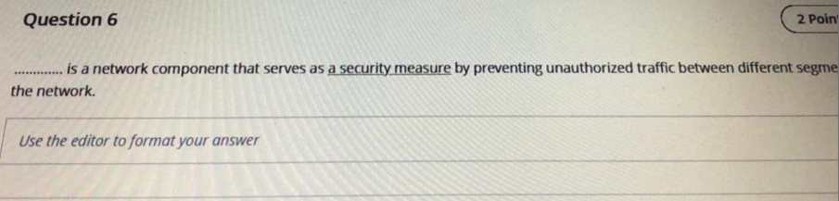

Firewalls  
Firewall systems are the primary tool that enable an organization to prevent unauthorized access between networks. An organization may choose to deploy one or more systems that function as firewalls. Routers can filter packets based on parameters, such as source address, but are not primarily a security tool. Based on Media Access Control (MAC) addresses, layer 2 switches separate traffic in a port as different segments and without determining if it is authorized or unauthorized traffic. A virtual LAN (VLAN) is a functionality of some switches that allows them to switch the traffic between different ports as if they are in the same LAN. Nevertheless, they do not deal with authorized vs. unauthorized traffic.

**Q7 Who is responsible for granting access to the data?**

Data owners should have the authority and responsibility for granting access to the data.

Data owners are responsible for the use of data. Written authorization for users to gain access to computerized information should be provided by the data owners. Security administration with the owners approval sets up access rules stipulating which users or group of users are authorized to access data or files and the level of authorized access (e.g., read or update).

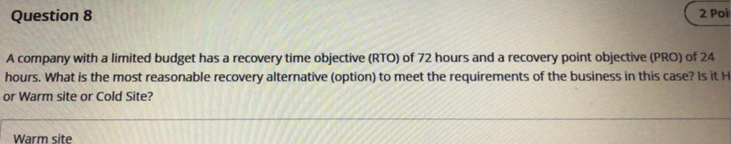

Warm Site A warm site is the most appropriate solution because it provides basic infrastructure and most of the required IT equipment to affordably meet the business requirements. The remainder of the equipment needed can be provided through vendor agreements within a few days. The RTO is the amount of time allowed for the recovery of a business function or resource after a disaster occurs. The RPO is determined based on the acceptable data loss in case of a disruption of operations. The RPO indicates the earliest point in time that is acceptable to recover the data, and it effectively quantifies the permissible amount of data loss in case of interruption.

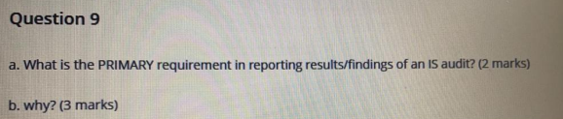

IS audit standards require that reports should be backed by sufficient and appropriate audit evidence so that they demonstrate the application of the minimum standard of performance and the findings and recommendations can be validated, if required.

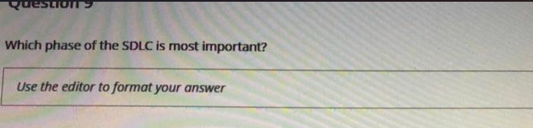

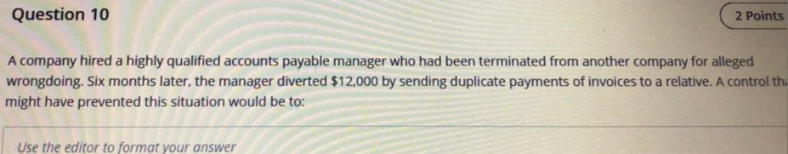

Preventative Controls that seek to stop (prevent) the problem from occurring. A simple example is prescreening job applicants for employment eligibility. Synonyms for preventative controls include words such as proactive or deterrent activities designed to discourage or stop a problem.

INPUT CONTROLS

Specifically Data validation which includes duplicate check.

Adequately check prior employment backgrounds for all new employees.

Because honest and capable personnel also help create an environment conducive to effective internal control, hiring policies and procedures are crucial. Background checks, for example, may screen out potential hires of questionable character and serve to prevent potential fraud.

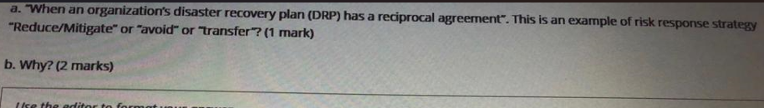

**Mitigation.**

Disaster Recovery plan through reciprocal agreement is one form of risk mitigation as it aims to minimize the potential impact of a disaster by having a plan in place for continuing operations in the event of an emergency. Thus this reciprocal agreement is a proactive approach towards risk management by implementing a risk mitigation strategy.

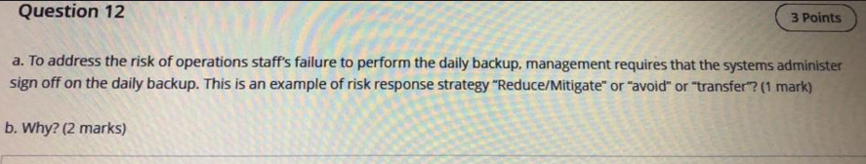

Mitigation is the strategy that provides for the definition and implementation of controls to address the risk described. Avoidance is a strategy that provides for not implementing certain activities or processes that would incur risk. Transference is the strategy that provides for sharing risk with partners or taking insurance coverage. Acceptance is a strategy that provides for formal acknowledgement of the existence of a risk and the monitoring of that risk.

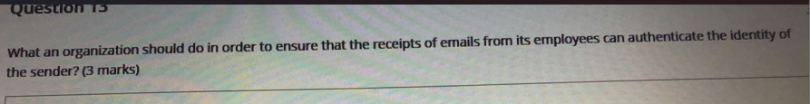

By digitally signing all e-mail messages, the receiver will be able to validate the authenticity of the sender. Encrypting all e-mail messages would ensure that only the intended recipient will be able to open the message; however, it would not ensure the authenticity of the sender. Compressing all email messages would reduce the size of the message, but would not ensure the authenticity. Password protecting all e-mail messages would ensure that only those who have the password would be able to open the message; however, it would not ensure the authenticity of the sender.

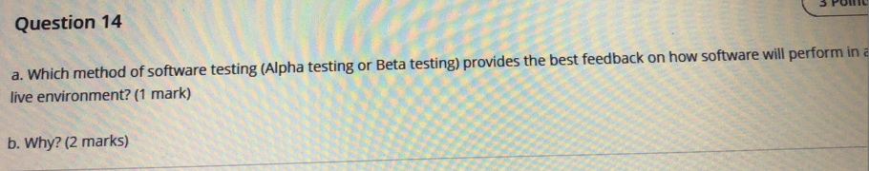

Alpha testing is a software testing process done by the developers for identifying all potential errors and problems before it is handed over to the end-user. Beta testing on the other hand done by users themselves in a real user environment to collect feedback and criticism about the software. The main differences between alpha and beta testing are as follows.

**Alpha Testing**

* It is a user acceptance testing process which involves the testing of design, structure, coding, and also the functionality of the software.
* It is done by the employees of the organization in a high scale development environment.
* Alpha testing requires more time and effort to test all the structure and functionality of the software and it ensures the quality of the product.

**Beta Testing**

* It is also a user acceptance testing process but it only tests the external functionality of the software.
* Beta testing is done by the real users themselves hired by the company to test the overall reliability and functionality of the software.
* It does not need a development environment and requires less time to accomplish the test.

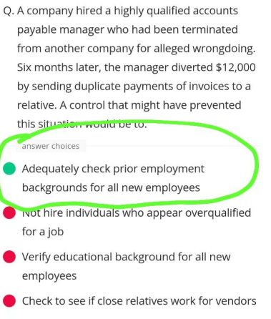

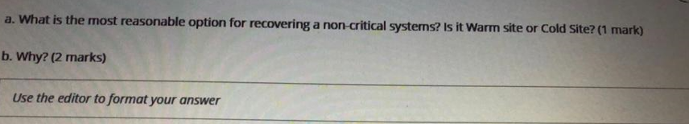

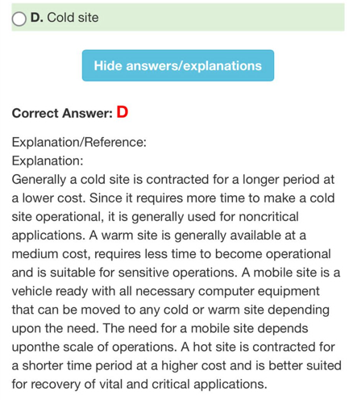

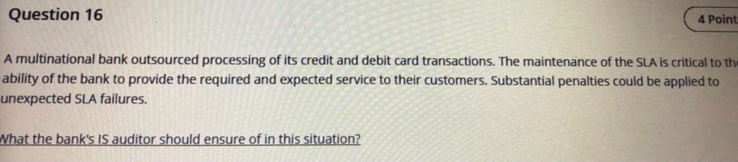

The bank's IS auditor should: – Verify that the agreed-on SLAs were achievable by the outsourcing vendor. – Verify that adequate and complete reports of SLA achievement were prepared by the vendor's IS department in good time for the monthly SLA management meetings.

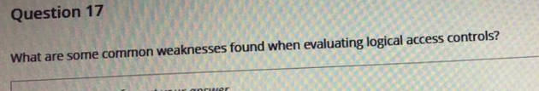

* Sharing user IDs between multiple people – eliminates accountability for user actions.
* Poor password quality (e.g., too short, easily guessed, not changed regularly) – increases risk that a password will become known and permit unauthorized access.
* Overly permissive access rules or rules granting access by default – increases risk of accidental or intentional unauthorized access to programs or data.
* Lack of security monitoring and follow-up – staff may be unaware of attacks against the system, or other error conditions, that may result in unauthorized access or other problems.

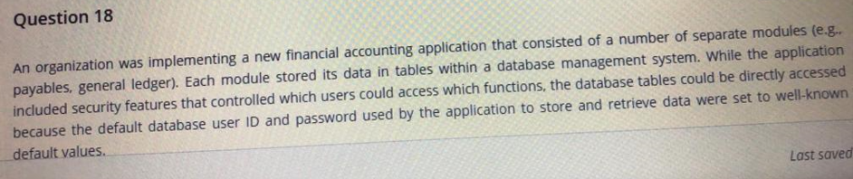

1. Where is the information security risk in this situation?

The security risk here is that knowledgeable users could bypass security within the application, and directly add or modify important business data.

1. What do you, as an IS audit expert, think could have been done to prevent this organization from being in this situation?

The organization's database management team should have been more aware of the security weakness due to default passwords. This could have been achieved if the organization had more detailed security governance (e.g., a security baseline prohibiting use of default passwords), and improved security awareness training

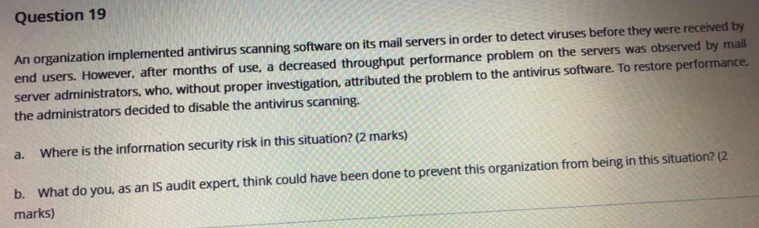

1. Where is the information security risk in this situation?

The security risk here is that large volumes of inbound mail, which should be scanned by the antivirus software, were not being scanned.

1. What do you, as an IS audit expert, think could have been done to prevent this organization from being in this situation?

The organization's server administrators should have been more aware of the importance of antivirus scanning as well as the fact that it was a required security procedure. Simply deciding to disable the scans should have been understood as an unacceptable breach of security governance.

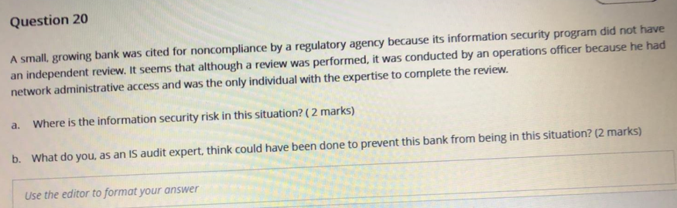

A 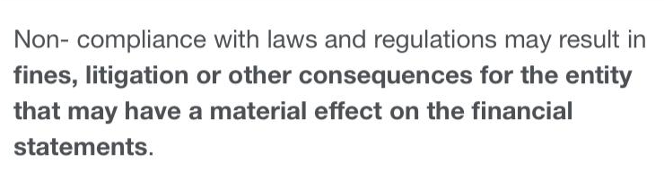

B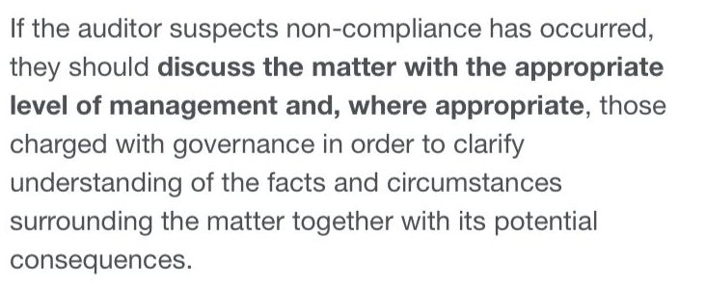

**A.**

**Information security risk in this situation is in the form that the person who performed the review is not independent, rather the person is responsible for internal operations and understanding of network administration. It means that any security lapses can be identified and corrected within the organization itself, but not reported in the documents of review. It means that the bank could come clean even if there was a security breach because it was done internally. It is the reason that this review is not recognized as an independent review and charge of noncompliance.**

**===**

**B.**

**To prevent this issue, the bank should appoint a reputed auditor agency and go for the audit of the information security system of the bank. Based on review and detailed audit process, done by the agency, the bank should disclose the information to the authorities and act upon the issues. Afterward, once the issues are resolved and duly recognized by the authorities, then charges of non-compliance will be eliminated.**

**An organization is using human resources (HR) management software that it had developed by a vendor several years ago. The software maintains confidential information typically kept in personnel files, such as salary levels and management reviews. On performing a review, the IS auditor found that there were no written policies or guidelines indicating the type of authentication necessary for accessing the information in the software and that the organization typically used a four-character password for all items requiring access controls.**

What is the risk associated with this situation?

Answer: The lack of sufficient access controls poses a serious risk to an organization's information integrity.

What do you, as an IS audit expert, think could have been done proactively to prevent this organization from being in this situation?

Answer: To prevent a situation like this from occurring, an organization should have proper access control policies, process, and strategies in place

**Q3:- Government regulations require that a major utility submit certain complex statistical information. To comply with the mandate, the organization used a database that had been created by a member of the finance department who had a great deal of business experience, but no formal IS training or experience with risk management. This large database embedded highly technical algorithms for calculating management information and had been in use for many years. The system used an old version of the database software which was no longer supported by the software vendor. No formal normalization had been carried out, although there was no evidence of data redundancy. Finally, there were no security or resilience controls in place. The database creator was about to retire and was the only person in the organization who had knowledge of the database and how to interpret the information analyses. The finance department management did not have an understanding of how the required data were collected and collated.**

What would you, as an IS auditor, recommend to management?

In this case, the IS auditor recommended:

– Create a new database using current software.

– Place the database on a network server, subject to network access controls and routine backups.

– Retain the staff member as a consultant to advise on the design and implementation of the new database.

**Q2:- A multinational bank outsourced processing of its credit and debit card transactions. The maintenance of the SLA is critical to the ability of the bank to provide the required and expected service to their customers. Substantial penalties could be applied to unexpected SLA failures.**

The bank's IS auditor should:

– Verify that the agreed-on SLAs were achievable by the outsourcing vendor.

– Verify that adequate and complete reports of SLA achievement were prepared by the vendor's IS department in good time for the monthly SLA management meetings.

**Q4:- A major financial processing organization involved with the authorization of credit card transactions at point of sale used software to manage its authorization and fraud control system that includes a large number of system utilities.**

**Some of these utilities have capabilities such as adding users or terminals, or starting and shutting down the system. An audit found that these utilities were contained in a library to which only authorized system support staff had access.**

**However, one utility that system support staff thought could be used only for simple interrogation (such as current usage statistics) was held in a globally available library.**

As an IS auditor, would you be concerned that a system utility was available to all users?

The auditor determined that it was possible, without even logging on, to access the mainframe and use the utility to request full statistical information on all of the hundreds of terminals currently connected to the authorization system

**Q5:- An organization wanted to better regulate their internal network traffic by installing a firewall between major portions of their network. IS management directed that this had to be accomplished by a specific date.**

**When management asked whether the firewall was installed by the date specified, the answer was "yes." However, what was not communicated was that, although the firewall installation was complete, no restrictive firewall rules were in place – instead, an "any-to-any" rule was in place, which allowed traffic to continue to flow freely throughout the network.**

Where is the information security risk in this situation?

• Although management was advised that the firewall was technically "in place," it was not providing the required controls over network traffic. In this situation the firewall was essentially just being used as a router.

• Accordingly, without implementing any restrictive firewall rules, there is a much greater risk of unauthorized access to network traffic and network-attached computing resources.

**Q7:- In addition to the usual Internet-facing firewall, an organization made use of internal firewalls to achieve various security zones within their network. This permitted, for example, better controlling access to production systems from users on the business office network.**

**A new business function and application being introduced within the organization required offering access to the Internet. Business-area management group responsible for the new application had IT connect this internal firewall directly to the internet as part of the deployment of this application.**

Where is the information security risk in this situation?

- Business unit management was able to bypass security requirements and the protection of the approved security architecture. As a result, internal networks and connected computing resources were exposed to attacks and other attempts through unauthorized access from the Internet.

**Q8:- A small, growing bank was cited for noncompliance by a regulatory agency because its information security program did not have an independent review. It seems that although a review was performed, it was conducted by an operations officer because he had network administrative access and was the only individual with the expertise to complete the review.**

Where is the lapse in effective IT governance in this situation?

The actual risk here is the lack of segregation of duty.

What do you, as an IS audit expert, think could have been done to prevent this bank from being in this situation?

If the bank had the proper IT organizational structure and resource management in place, including proper segregation of duties and duty controls, this situation may not have occurred.

**EXTRA STUFF**

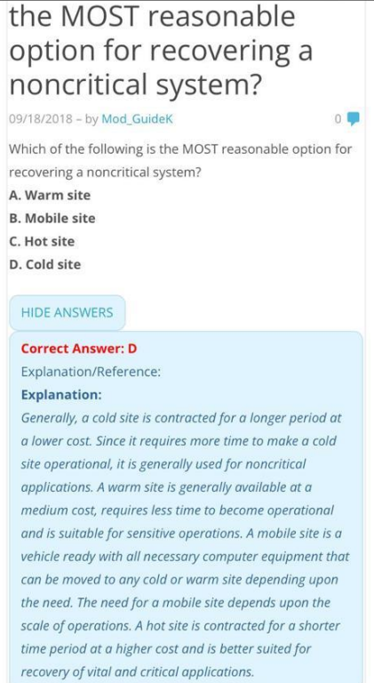

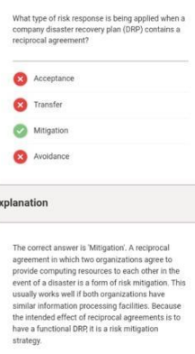

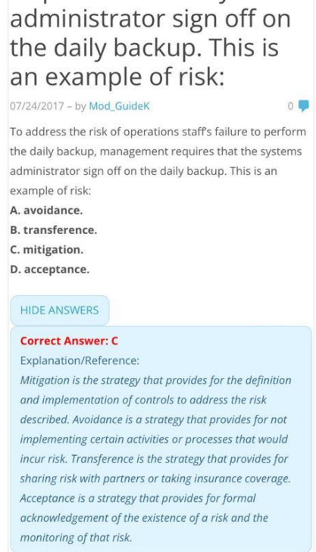

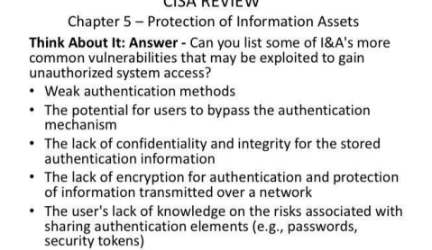

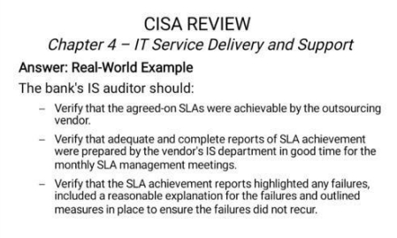

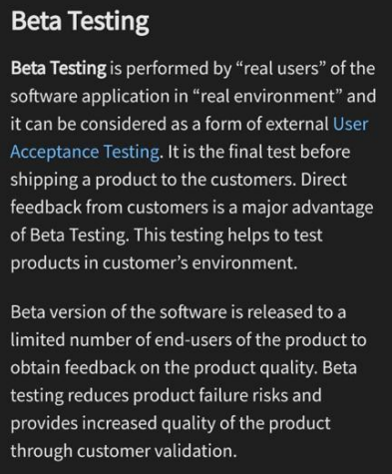

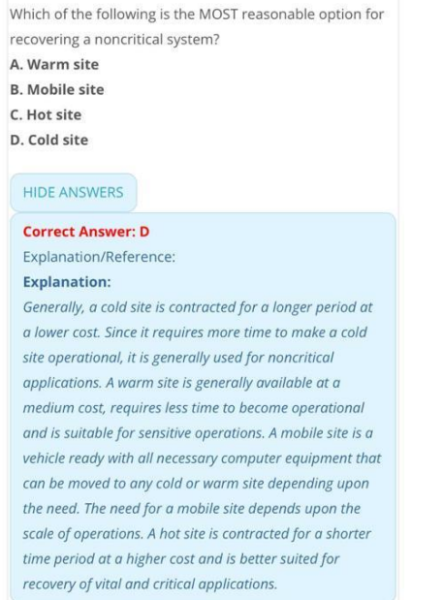

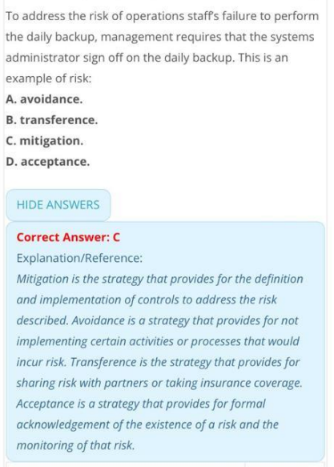

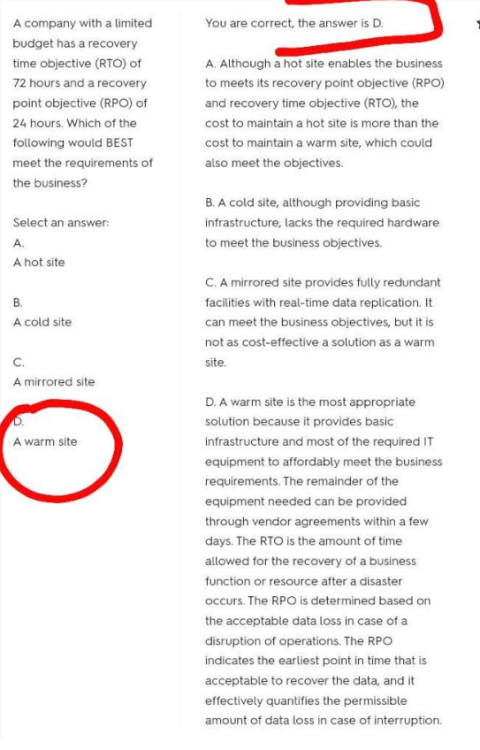

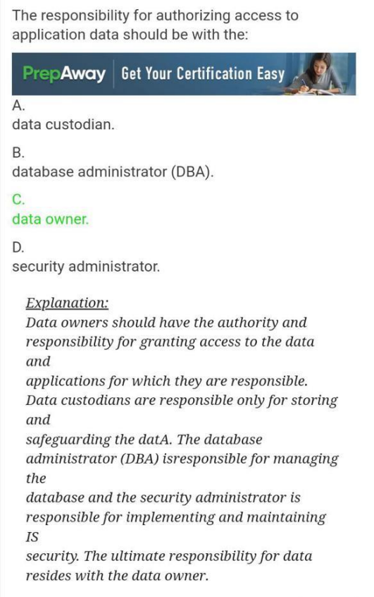

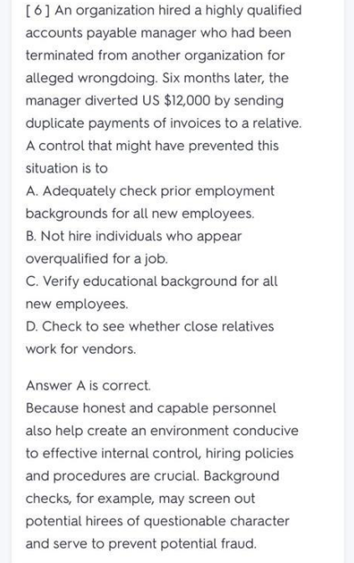

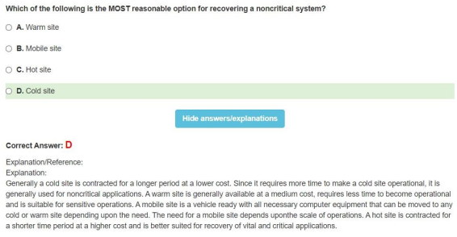

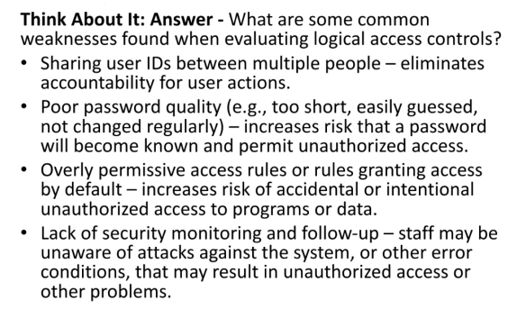

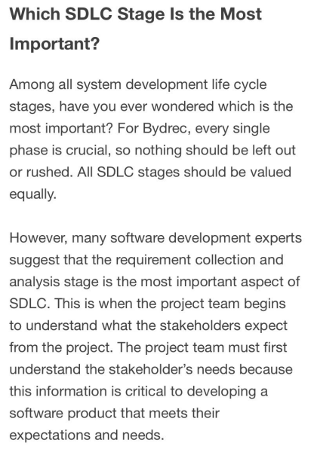

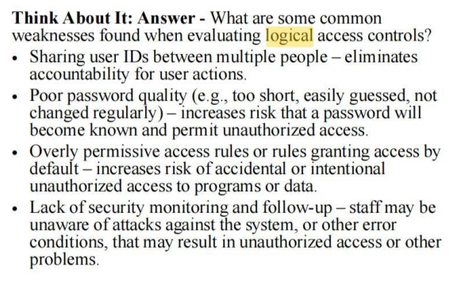

**Part 2**

1. What is the role of IS auditor in a software acquisition study? List any four roles.

* Analyse the documentation from the feasibility study to determine whether the decision to acquire a solution was appropriate (including consideration of common criteria evaluations).
* Review the RFP to ensure that it covers the items listed in this section.
* Determine whether the selected vendor is supported by RFP documentation.
* Ensure the contract is reviewed by legal counsel before it is signed.
* Review the RFP to ensure security responses are included by the vendor.

1. Explain the following with an example:

* Input Controls:

Input controls ensure that only valid and authorized information are input and that these transactions are only processed once.

* Application Controls:

Only complete, accurate and valid data are entered and updated in a computer system.

Processing accomplishes the correct task.

Processing results meet expectations.

Data are maintained.

* Output Controls:

Output controls provide assurance that the data delivered to users will be presented, formatted, and delivered in a consistent and secure manner.

1. List FOUR key elements in information security management.

* **Senior Management Commitment and support**
* **Policies and Procedures**
* Organization
* **Security Awareness and Training**
* Monitoring and compliance, and
* **Incident handling and response**

1. What does an IS Auditor assess in the Systems Development Lifecycle (SDLC). Provide any FOUR areas.

* **Obtain documentation from the various phases**
* Attend project team meetings
* Offering advice to the project team throughout the system development process.
* **Objectives defining what is to be accomplished during that phase**
* **Key deliverables by phases with project personnel assigned direct responsibilities for these deliverables**
* **A project schedule with highlighted dates for the completion of key deliverables**
* An economic forecast for that phase, defining resources and the cost of the resources required to complete the phase

1. In your assignment, you performed an IS audit on an organization. Explain any THREE main observations/findings gathered from your audit.

* Physical access to hardware facilities is not restricted
* Hardware equipment is not tagged properly
* The current hardware being used by the Company is outdated and no longer supported by the manufacturer
* Missing proper hardware disposal policy

**Part 3**

1. How does an IS auditor ensures that the development and design of project are managed and governed properly?  
   An Information Systems (IS) auditor can ensure that the development and design of a project are managed and governed properly by performing a variety of tasks, such as:
   1. Reviewing project plans, requirements, and design documents to ensure they are in compliance with company policies and standards.
   2. Monitoring the progress of the project to ensure it stays on schedule and within budget.
   3. Verifying that the project is being executed in accordance with industry best practices and standards.
   4. Conducting testing of the system to ensure it meets the requirements defined in the project documentation.
   5. Evaluating the system's security controls to ensure they are adequate to protect against unauthorized access or misuse.
   6. Reviewing change management procedures to ensure they are being followed and that changes are properly authorized and tracked.
   7. Conducting compliance reviews to ensure the project is in compliance with relevant laws and regulations.
   8. Reviewing incident management procedures to ensure they are effective and that incidents are being handled in a timely and appropriate manner.
   9. Evaluating the effectiveness of the project's governance structure and making recommendations for improvements if necessary.
   10. Documenting the results of the audit and making recommendations for any necessary corrective actions to address any issues identified.

These are some examples of activities but it will vary according to the specifics of the project and organization.

* 1. Levels of oversight by project committee/board
  2. Risk management methods
  3. Issue management
  4. Cost management
  5. Processes for planning and dependency management
  6. Reporting processes
  7. Change control processes
  8. Stakeholder management involvement
  9. Sign-off process

1. During the feasibility study of a project, explain any THREE activities an IS auditor should perform?
   1. Review the documentation for the phase to ensure that it is reasonable.
   2. Determine whether all cost justifications/benefits are verifiable and that they show the anticipated costs and expected benefits.
   3. Identify and determine the criticality of the need.
   4. Determine if a solution can be achieved with systems already in place. If not, review the evaluation of alternative solutions for reasonableness.
   5. Determine the suitability of the chosen solution.
2. Explain any FOUR types of testing the IS auditor performs on a system.

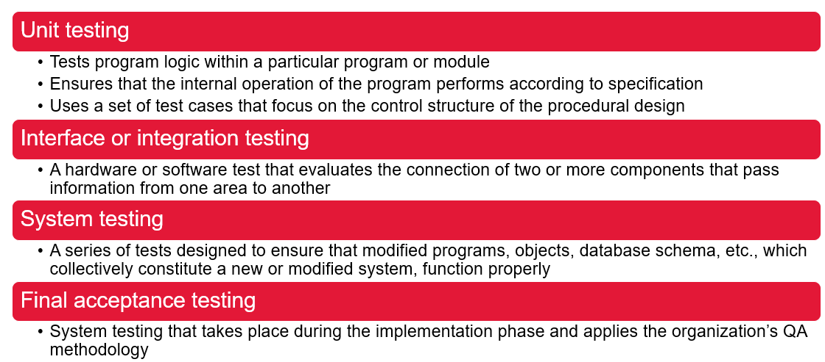

1. When determining system requirements, the IS auditor should perform some activities. Explain any THREE of his roles in this phase.
   1. **Obtain detailed requirements definition**
   2. **Identify key team members**
   3. **Verify that project initiation and cost received proper management approval**
   4. Review the UAT specification
2. How does the IS auditor ensure that application controls of IT systems are effective?
   1. Identifying **significant application components** and the flow of transactions
   2. Identifying **the application control strengths** and evaluating the impact of the control weaknesses
   3. Developing a **testing strategy**
   4. **Testing the controls** to ensure their functionality and effectiveness
3. How does an IS auditor assess whether the IT strategies are aligned to the organization strategy?

According to the Certified Information Systems Auditor (CISA) standards, an IS auditor should assess whether IT strategies are aligned with the organization's overall strategy by performing the following steps:

Review the organization's overall strategy: The IS auditor should review the organization's mission statement, strategic goals, and objectives to gain an understanding of the organization's direction and priorities.

Review IT governance: The IS auditor should review the organization's IT governance policies and procedures to ensure that they align with the organization's overall strategy and objectives. This includes reviewing the roles and responsibilities of IT management, the IT strategic planning process, and the IT budgeting process.

Assess IT performance: The IS auditor should assess the performance of IT in support of the organization's overall strategy. This includes evaluating the effectiveness of IT activities and investments in supporting the organization's objectives and identifying any critical IT risks that may impact the organization.

Evaluate IT risk management: The IS auditor should evaluate the organization's IT risk management process to ensure that it is aligned with the organization's overall strategy and objectives. This includes assessing the effectiveness of the organization's IT controls in mitigating IT risks and ensuring compliance with laws, regulations, and industry standards.

Communicate findings: The IS auditor should communicate any findings and recommendations to the appropriate parties, such as the audit committee, management, and IT leadership. This may include recommendations for aligning the IT strategies with the organization's overall strategy and for addressing any identified risks.

Evaluate Continuity plans: Finally, IS auditor should evaluate the organization's IT continuity plans, including disaster recovery and business continuity plans, to ensure they align with the organization's overall strategy and objectives and that they have been regularly tested and updated to adapt to changing environment and technology.

It's worth mentioning that CISA requires auditors to follow the IS Auditing Standards and Guidelines to perform their audits, it's also important for IS auditor to be familiar with the organization's business objectives and IT environment.

1. How does an IS Auditor ensure that proper environment controls are in place in the organization?
   1. Water and smoke detectors logs
   2. Fire suppression system documentation
   3. UPS/generator test reports
   4. Electrical surge protectors
   5. Humidity and temperature controls

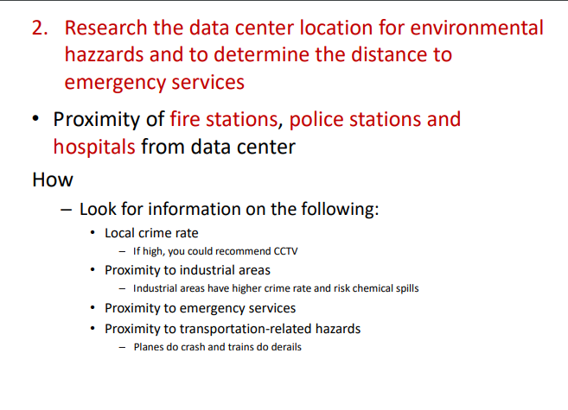

1. How does the IS auditor review the IT strategic planning process of the organization and ensure that it aligns with business strategies? Provide and FOUR ways he can assess this.

An IS auditor can review the IT strategic planning process of an organization to ensure that it aligns with the organization's overall business strategies in a number of ways, including:

Review IT Governance policies: The IS auditor should review the organization's IT governance policies and procedures to ensure that they provide a framework for the IT strategic planning process and that the process aligns with the organization's overall business strategies.

Assess the IT strategic planning process: The IS auditor should assess the IT strategic planning process to ensure that it is well-defined, formalized and inclusive, for the IT and business team, this process should consider the organization's current and future IT needs and should align with the organization's overall business strategies.

Evaluate the alignment of IT strategies: The IS auditor should evaluate the alignment between the organization's overall business strategies and its IT strategies. This may involve identifying specific objectives or goals that are supported by IT and determining whether the IT strategies are helping to achieve the organization's overall business objectives.

Identify the relationship between IT and Business : The IS auditor should evaluate the relationship between the IT and business team and identify any issues that could impact the alignment between the IT and business strategy. this could include communication barriers, lack of understanding of each other's responsibilities, or lack of integration between the two teams.

It's worth mentioning that the IS auditor should also evaluate the effectiveness of IT strategic planning process by measuring the performance of IT and assessing the risks that could impact the alignment with business strategies and should make recommendations for improvements if necessary.

Controls (corrective, preventive,dedective)

Risk Responses Management strategies.

**Accept:** Take your chances. Ignoring risk is the same as accepting Risk. The auditor should be concerned of the acceptance of the high-risk situation.

**Mitigate:** Do something to lower the odds of getting hurt. The purpose of mitigation is to lower the effects of potential damage. Most internal controls are design to mitigate risk.

**Transfer:** Let someone else take the chance of loss by using a subcontractor or insurance. You can transfer the risk but not the liability of the failure.

**Avoid:** Reject the situation change the situation and avoid taking risk.

Project management phases

An audit charter outlines your responsibility, authority, and accountability:

– Responsibility Provides scope with goals and objectives

– Authority Grants the right to perform an audit and the right to obtain access relevant to the audit

– Accountability Defines mutually agreed-upon actions between the audit committee and the auditor, complete with reporting requirements

**PHYSICAL ACCESS AND ENVIRONMENTAL** CONTROLS Evaluate the design, implementation, maintenance, monitoring and reporting of physical and environmental controls to determine whether information assets are adequately safeguarded.

**The IS auditor should evaluate the following criteria for defining permissions and granting**

**access:**

• Need-to-know

• Accountability

• Traceability

• Least privilege

• SoD

**Difference between incident management and problem management**

Incident management and problem management are both processes used in IT service management, but they serve different purposes.

Incident management is the process of restoring normal service operation as quickly as possible, and minimizing the adverse impact on business operations. This includes identifying, diagnosing, and resolving incidents, as well as restoring normal service operation. The goal of incident management is to restore normal service operation as quickly as possible, and to minimize the adverse impact on business operations.

Problem management, on the other hand, is the process of identifying the root cause of one or more incidents, and taking steps to prevent them from happening again. This includes identifying, diagnosing, and resolving problems, as well

**Data leak prevention** is a suite of technologies and associated processes that locate,

monitor and protect sensitive information from unauthorized disclosure.

DLPs have three key objectives:

• Locate and catalog sensitive information stored throughout the enterprise.

• Monitor and control the movement of sensitive information across enterprise networks.

• Monitor and control the movement of sensitive information on end-user systems.

Digital signature schemes ensure:

• Data integrity— Any change to the plaintext message would

result in the recipient failing to compute the same document

hash.

• Authentication—The recipient can ensure that the document

has been sent by the claimed sender because only the claimed

sender has the private key.

• Nonrepudiation—The claimed sender cannot later deny

generating the document.

The IS auditor should be familiar with how a digital

signature functions to protect data.

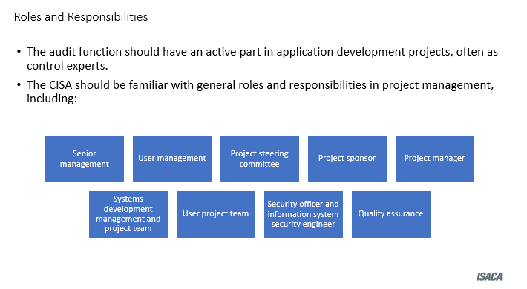

During the feasibility study, the IS auditor should perform the following:

**Review the documentation** for the phase to ensure that it is reasonable.

**Determine whether all cost justifications/benefits** are verifiable and that they show the anticipated costs and expected benefits.

**Identify and determine the criticality of the need.**

**Determine if a solution can be achieved with systems already in place.** If not, review the evaluation of alternative solutions for reasonableness.

**Determine the suitability of the chosen solution.**

Projects have a finite life. Once the project is closed, it is handed over to end users.

During project closure:

Assign outstanding issues.

Assign custody of contracts.

Archive or hand off documentation.

Discuss lessons learned.

Conduct a post-project review.

1. **Which of the following is the MOST important skill an IS auditor should develop to understand the constraints of conducting an audit? * (0.5 Points)**
2. Contingency planning
3. IS management resource allocation
4. Project management
5. Project management
6. **A database administrator has detected a performance problem with some tables, which could be solved through denormalization. This situation will increase the risk of: * (0.5 Points)**
7. concurrent access
8. deadlocks
9. unauthorized access to data
10. a loss of data integrity
11. **Due to resource constraints of the IS audit team, the audit plan as originally approved cannot be completed. Assuming that the situation is communicated in the audit report, which course of action is MOST acceptable? * (0.5 Points)**
12. Test the adequacy of the control design
13. Test the operational effectiveness of controls.
14. Focus on auditing high-risk areas.
15. Rely on management testing of controls
16. **Which of the following is the BEST factor for determining the required extent of data collection during the planning phase of an IS compliance audit? * (0.5 Points)**
17. Complexity of the organization's operation
18. Findings and issues noted from the prior year
19. Purpose, objective and scope of the audit
20. Auditor's familiarity with the organization
21. **"Completing programmed edit checks" is an example of * (0.5 Points)**
22. Detective control
23. Corrective control
24. Preventative control
25. Functional Control
26. **An IS auditor is developing an audit plan for an environment that includes new systems. The company's management wants the IS auditor to focus on recently implemented systems. How should the IS auditor respond? * (0.5 Points)**
27. Audit the new system as requested by the management
28. Audit systems not included in the last year's scope.
29. Determine the highest-risk systems and plan accordingly.
30. Audit both the systems not in the last year's scope and the new system.
31. **Match the following to its corresponding IS audit procedure: "Logon ID and Password" (0.5 Points)**
32. Verifying that passwords are changed periodically
33. Analyze global configuration settings for password strength in the system application and compare this with the organization's security policy.
34. Attempts to access computer transactions or data for which access is not authorized
35. Looking for special system maintenance logon IDs, operating system exits, installation utilities and input/output (1/0) devices
36. **Match the following to its corresponding description: "Piggybacking" (0.5 Points)**
37. Hiding fraudulent code in an authorized or falsely authorized computer program
38. Slicing off small amounts of money from a computerized transaction or account
39. Disrupts or completely denies service to legitimate users
40. Electronically attaching to an authorized telecommunications link to intercept and alter transmissions
41. **Match the following to its corresponding IS audit procedure: "Review Access Controls and. Password Administration" * (0.5 Points)**
42. Verifying that passwords are changed periodically
43. Analyze global configuration settings for password strength in the system application and compare this with the organization's security policy.
44. Attempts to access computer transactions or data for which access is not authorized
45. Looking for special system maintenance logon IDs, operating system exits, installation utilities and input/output (1/0) devices
46. **With the help of a security officer, granting access to data is the responsibility of: * (0.5 Points)**
47. data owners
48. programmers.
49. system analysts.
50. librarians.
51. **Which of the following environmental controls is appropriate to protect computer equipment against short-term reductions in electrical power? (0.5 Points)**
52. Power line conditioners
53. Surge protective devices
54. Alternative power supplies
55. Interruptible power supplies
56. **... support the implementation of a comprehensive governance and management system. (0.5 Points)**
57. Enablers
58. Processes
59. Principles, Policies and Frameworks
60. IT Related Goals
61. **Why is COBIT 5 considered to be an integrated framework? * (0.5 Points)**
62. It integrates enterprise goals with IT-related goals
63. It integrates in any governance system
64. It integrates IT-related goals with enablers
65. It aligns with other relevant standards
66. **for a new system should identify both intangible benefits and return on investment. (0.5 Points)**
67. A feasibility study
68. An impact assessment
69. A business case
70. A value analysis
71. **Which of the following is the BEST indicator of the effectiveness of backup and restore procedures while restoring data after a disaster? (0.5 Points)**
72. Members of the recovery team were available.
73. Recovery objectives (RTOS) were met.
74. Inventory of backup tapes was properly maintained.
75. Backup tapes were completely restored at an alternate site.
76. **Which of the following would BEST help to prioritize project activities and determine the time line for a project? * (0.5 Points)**
77. A Gantt chart
78. Earned value analysis (EVA)
79. Program evaluation review technique (PERT)
80. Function point analysis (FPA)
81. **When reviewing an active project, an IS auditor observed that the business case was no longer valid because of a reduction in anticipated benefits and increased costs. The IS auditor should recommend that the: (0.5 Points)**
82. project be discontinued
83. business case be updated and possible corrective actions be identified.
84. project be returned to the project sponsor for reapproval.
85. project be completed and the business case be updated later.
86. **Which of the following issues should be a MAJOR concern to an IS auditor is reviewing a service level agreement (SLA)? * (0.5 Points)**
87. A service adjustment resulting from an exception report took a day to implement
88. The complexity of application logs used for service monitoring made the review difficult.
89. Performance measures were not included in the SLA.
90. The document is updated on an annual basis.
91. **Which of the following processes should an IS auditor recommend to assist in the recording of for software releases?* (0.5 Points)**
92. Change management
93. Backup and recovery
94. Incident management
95. Configuration management
96. **Which of the following specifically addresses how to detect cyberattacks against an organization's IT systems and how to recover from an attack? (0.5 Points)**
97. An incident response plan (IRP)
98. IT contingency plan
99. A business continuity plan (BCP)
100. A continuity of operations plan (COOP)
101. Classify the following controls as **preventive**, **detective** or **corrective**: * (4 Points)

|  |  |  |
| --- | --- | --- |
|  | **CONTROL** | **TYPE** |
| **1** | Employ only qualified personnel ? | Preventive |
| **2** | Control access to physical facilities | Preventive |
| **3** | Contingency planning | corrective |
| **4** | Checking hash totals | detective |

**QUESTION 1**

**During an exit interview, in cases where there is disagreement regarding the impact**

**of a finding, an IS auditor should:**

* ask the auditee to sign a release form accepting full legal responsibility
* elaborate on the significance of the finding and the risks of not correcting it.
* report the disagreement to the audit committee for resolution
* accept the auditee’s position since they are the process owners.

**QUESTION 2 10 points**

**Which of the following is NOT a benefit of CSA?**

* Improved audit rating process
* Audit replacement
* Damage employee morale
* Regarded as additional workload

**QUESTION 3 10 points**

**The success of control self-assessment (CSA) depends highly on:**

* having line managers assume a portion of the responsibility for control monitoring.
* assigning staff managers the responsibility for building, but not monitoring, controls.
* the implementation of a stringent control policy and rule-driven controls.
* the implementation of supervision and the monitoring of controls of assigned duties.

**QUESTION 4 10 points**

**Corrective action has been taken by an auditee immediately after the identification of**

**a reportable finding. The IS auditor should:**

* include the finding in the final report, because the IS auditor is responsible for an accurate report of all findings.
* not include the finding in the final report, because the audit report should include only unresolved findings.
* not include the finding in the final report, because corrective action can be
* verified by the IS auditor during the audit
* include the finding in the closing meeting for discussion purposes only.

**QUESTION 5 10 points**

**When developing a risk-based audit strategy, an IS auditor should conduct a risk assessment to ensure that:**

* controls needed to mitigate risks are in place.
* vulnerabilities and threats are identified.
* audit risks are considered.
* a gap analysis is appropriate.

**QUESTION 6 10 points**

**Which of the following is NOT a risk response:**

* Risk Migitation
* Risk Sharing
* Risk Avoidance
* Risk Solution

**QUESTION 7 10 points**

**After reviewing the disaster recovery plan (DRP) of an organization, an IS auditor requests a meeting with company management to discuss the findings. Which of the following BEST describes the main goal of this meeting?**

* Obtaining management approval of the corrective actions
* Confirming factual accuracy of the findings
* Assisting management in the implementation of corrective actions
* Clarifying the scope and limitations of the audit

**QUESTION 8 10 points**

**Which of the following is NOT a step in IS Audit planning:**

* Perform a risk analysis
* Set the audit scope and audit objectives.
* Assign personnel resources to the audit
* Confirm audit findings and approach with management

**QUESTION 9 10 points**

**What is the role of the IS auditor in meeting the objecties of Control Self Assessment?**

* Facilitate and guide the auditees in assessing their environment by providing insight about the objectives of controls based on the risk assessment.
* Design the audit
* Monitor the audit
* Under take the full responsiblility of CSA

**QUESTION 10 10 points**

**Which of the following is the MOST critical step to perform when planning an IS audit?**

* Review findings from prior audits
* Develop plans to conduct a physical security review of the data center facility
* Review IS security policies and procedures
* Perform a risk assessment.

**Question 1**

An IS auditor has been asked by management to review a potentially fraudulent transaction. The **PRIMARY** focus of an IS auditor while evaluating the transaction should

* maintain impartiality while evaluating the transaction.
* ensure that the independence of an IS auditor is maintained.
* assure that the integrity of the evidence is maintained.
* collect all relevant evidence for the transaction.

**Question 2**

What is the difference between a threat and a vulnerability?

* Threats are the path that can be exploited by a vulnerability
* Threats are risks and become a vulnerability if they occur.
* Vulnerabilities are a path that can be taken by a threat, resulting in a loss.
* Vulnerability is a negative event that will cause a loss if it occurs

**1.** A lack of adequate controls represent "vulnerability" **(1/1 Point)**

* True
* False

**2.** "Reviewing past-due account reports" is an example of Detective control **(1/1 Point)**

* True
* False

**3.** Shut down the system when risks are identified is an example of risk response strategy "Reduce/Mitigate" **(1/1 Point)**

* True
* False

**4.** Switching to cloud-based solutions is an example of risk response strategy "Avoid" * **(1/1 Point)**

* True
* False

**5.** To reduce the risk of unauthorized entry into your company building, you could install a badge system which is an example of risk response strategy "Reduce/Mitigate"* **(1/1 Point)**

* True
* False

**6.** Which of the following is the MOST important skill an IS auditor should develop to understand the constraints of conducting an audit?* **(1/1 Point)**

a. Contingency planning

b. IS management resource allocation

c. Project management

d. Knowledge of internal controls

**7.** Which of the following is the BEST factor for determining the required extent of data collection during the planning phase of an IS compliance audit? **(1/1 Point)**

a. Complexity of the organization's operation

b. Findings and issues noted from the prior year

C. Purpose objective and scope of the audit

d. Audit's familiarity with the organization

**8**. An IS auditor is developing an audit plan for an environment that includes new systems. The company's management wants the IS auditor to focus on recently implemented systems. How should the IS auditor respond? * **(1/1 Point)**

a. Audit the new system as requested by the management

b. Audit systems not included in the last year's scope

c. Determine the highest-risk systems and plan accordingly

d. Audit both the systems not in the last year's scope and the new system

**9.** During an audit, an IS auditor notices that the IT department of a medium-sized organization has no separate risk management function, and the organization's operational risk documentation only contains a few broadly described types of IT risk. What is the MOST appropriate recommendation in this situation?* **(1/1 Point)**

a. Create an IT risk management department and establish an IT risk framework with the aid of external risk management experts

b. Use common industry standard aids to divide the existing risk documentation into several individual types of risk which will be easier to handle

c. No recommendation is necessary because the current approach is appropriate for a medium-sized organization

d. Establish regular IT risk management meetings to identify and assess risk, and create a mitigation plan as input to the organization's risk management

**(1/1 Point)**

**10.** Although management has stated otherwise, an IS auditor has reasons to believe that the organization is using software that is not licensed. In this situation, the IS auditor should FIRST:

a. include the statement from management in the audit report

b. verify the 5oftware is in use through testing

c. include the item in the audit report

d. discuss the issue with senior management because it could have a negative impact on the organization

**11.** Classify the following controls as preventive, detective or corrective: **(-/5 Points)**

|  |  |  |
| --- | --- | --- |
|  | **CONTROL** | **TYPE** |
| 1 | Using Intrusion detection systems | Detective |
| 2 | Using antivirus software | Preventive |
| 3 | CCTV and surveillance camera logs | Detective |
| 4 | re-issue access cards | Preventive |
| 5 | implement a business continuity plan or incident response plan | Corrective |

**12.** Classify the following examples as control, detection, inherent risks: * **(-/5 Points)**

|  |  |  |
| --- | --- | --- |
|  | **CONTROL** | **TYPE** |
| 1 | A rapid change of business | Inherent |
| 2 | A clear understanding of audit objectives and scope of audit | Detection |
| 3 | There's no segregation of duties at the client side | Control Risk |
| 4 | high judgment or justification from management | Inherent |
| 5 | The supplier selection process isn't transparent | Control |

**13.** Internal audit department is being asked by IT department to share scripts that have been developed by audit to perform continuous auditing of some information systems.

**Would this affect IS auditors independence and objectivity to audit the IT function? and Why? (-/3 Points)**

The IT department should aim to use the scripts for regular and constant examination and monitoring while keeping in mind that it is accountable for testing and managing the scripts that is being used by it.

**14.** An IS auditor issues an audit report pointing out the lack of firewall protection features at the perimeter network and recommends a specific vendor product to address this vulnerability.

**What is wrong with the auditor comment?** **(-/3 Points)**

When an IS auditor proposes a particular vendor, they can be subjected to their professional independence Organizational independence has no influence on the contents of an audit report and should be taken into account before approving the agreement

IS auditor mustn’t approve any given vendor product due to difference in their opinion/interests. IS auditor can only recommend that a firewall is needed to be installed but cannot recommend a vendor directly

**15.** As IS auditor interviewing a payroll clerk finds that the answers do not support job descriptions and documented procedures.

**Under these circumstances, what should the IS auditor do?** * **(-/3 Points)**

It is right to broaden the definition to include substantive research. If the answers given to an IS auditor's questions are not supported by recorded standards or guidelines or policies descriptions, the IS auditor should broaden the scope of control testing and include additional strong assessments.

**16.** What is the purpose behind obtaining sufficient and appropriate audit evidence? * **(-/3 Points)**

The aim of obtaining adequate audit documentation/report is to provide a fair framework to justify the conclusion outlined in an agreement.

This makes the outcomes/actions take more justified and brings more fareplay.

17. An IS auditor is verifying IT policies and found that some of the policies have not ben approved by management (as required by the policy), but the employees strictly follow the policies.

**What should the IS auditor should do in this situation?**

**and why? * (-/4 Points)**

The IS auditor should report the absence of document approval.

Reason: The result must be recorded by the IS auditor. Even if the policies are followed, unapproved policies may pose a danger to the company since this technicality may prohibit management from applying the policies in certain situations and may raise legal problems. For example, if an employee was fired for breaking a corporate policy and it was then found that the rules had not been accepted, the company could face a very costly lawsuit

**18.** How is the internal audit functions can be conducted and by whom?

**please explain in details** * **(-/14 Points)**

This involves auditors within their own organization looking to discover evidence of what is occurring within an organization. Internal audit's function is to provide independent verification that an organization's risk assessment, governance, and internal control mechanisms are working properly. This is generally the board of directors or trustees, the financial clerk, or the audit committee who conduct it.

**Question 1 3 out of 3 points**

List THREE Code of Conduct (ethics) for an IS Auditor

* ISACA code of conduct for CISA professionals:
  1. Auditors agree to support the implementation of appropriate policies, standards, guidelines, and procedures for information systems. They will also encourage compliance with this objective.
  2. Auditors agree to perform their duties with **objectivity**, **professional care**, and **due diligence** in accordance with professional standards implementing the use of best practices.
  3. Auditors agree to serve the interests of stakeholders in an honest and lawful manner that reflects a credible image upon their profession
  4. Auditors promise to maintain privacy and confidentiality of information obtained during their audit except for required disclosure to legal authorities
  5. Auditors agree to undertake only those activities in which **they are professionally competent** and will strive to improve their competency. Their effectiveness in auditing depends on how evidence is gathered, analyzed, and reported.
  6. Auditors promise to disclose accurate results of all work and significant facts to the appropriate parties.
  7. Auditors agree to support ongoing professional education to help stakeholders enhance their understanding of information systems security and control.
  8. The **failure of a CISA to comply with this code of professional ethics** may result in an investigation with possible sanctions or disciplinary measures.

**Question 2 1 out of 1 points**

Which of the following statements is NOT true regarding the audit committee:

They ensure the accuracy and completeness of all reports provided to the securities & exchange commission (SEC)

**Question 3 1 out of 1 points**

During a change control audit of a production system, an IS auditor finds that the change management process is not formally documented and that some migration procedures failed. What should the IS auditor do next?

Finding more evidence and tracking to the main cause.

**Question 4 4 out of 4 points**

List any FOUR IS control procedures.

* + Strategy and direction of the IT function
  + General organization and management of the IT function
  + Access to IT resources, including data and programs
  + Systems development methodologies and change control

Additional IS control procedures include:

* + Operations procedures
  + Systems programming and technical support functions
  + Quality assurance (QA) procedures
  + Physical access controls
  + Business continuity planning (BCP)/disaster recovery planning (DRP)
  + Networks and communications
  + Database administration
  + Protection and detective mechanisms against internal and external attacks

**Question 5 3 out of 3 points**

How does the IS auditor ensure that burglar alarms and surveillance systems are protecting the data center from physical intrusion. List any three ways used by the auditor.

Verify that critical areas of data centers are covered by intrusion sensors, CCTV, audio surveillance systems or combination.

* + Motion sensors detect infrared motion
  + Contact sensors that are placed on windows and doors to detect when they are opened or broken
  + Audio sensors to detect breaking glass or changes in normal ambient noise
  + Door prop alarms to detect if door is left open after a period of time
* Review camera quality and placement.
* Verify that surveillance systems are monitored and evaluate the frequency of monitoring
* Verify that CCTV is recorded for play back

**Question 6 3 out of 3 points**

Three benefits of Control Self Asssessment and Three disadvantages of Control Self Assessment. Please list them

|  |  |  |
| --- | --- | --- |
| No | Advantages | Disadvantages |
| 1 | Early detection of risk | Mistaken as an audit function replacement |
| 2 | More effective and improved internal controls | Regarded as an additional workload |
| 3 | Creation of cohesive teams through employee involvement | Failure to act on improvement suggestions could damage employee morale |
| 4 | Developing sense of ownership | Lack of motivation may limit effectiveness in the detection of weak controls |
| 5 | Increased employee awareness |  |
| 6 | Increased communication |  |
| 7 | Improved audit rating process |  |
| 8 | Reduction in control cost |  |
| 9 | Assurance provided to stakeholders and customers |  |

**Question 7 3 out of 3 points**

How does the IS auditor ensure that a Disaster Recovery Planning (DRP) exists and is comprehensive and that key employees are aware of their roles in the event of a disaster.

**Please provide three ways.**

**Answer:**

* + Ensure that DRP exists
  + Verify that DRP covers all systems and operational areas. It should include a detailed step-by-step instruction for restoring critical systems.
  + Ensure that roles and responsibilities are clearly defined.
  + Ensure emergency communications are addressed in the plan
  + Determine whether the plan includes criteria for determining whether a situation is a disaster and procedures for declaring a disaster
  + Verify that a current copy of DRP is maintained at secured off-site location

1. Ensure that DRPs are updated and tested regularly
   * If plans are not tested, there is no assurance that they will work when need.
   * They should be updated at least annually
   * Failure to update or test DRPs will result in slower recover times in the event of a disaster

How

* + Review the update or version history of the plan
  + Verify that tests are performed at least annually

1. Ensure that emergency operations plans address various scenarios adequately

**Question 8** **3 out of 3 points**

How does the IS auditor verify that Heating Ventilation and Air Conditioning (HVAC) systems maintains constant temperatures within the data center? Please provide any three ways the IS Auditor uses to verify this.

**Answer:**

* Temperature and humidity logs- Determine how the data center staff has established the parameters for the equipment.
* Temperature and humidity alarms
* HVAC design to verify that all areas of the data centers are covered appropriately.
* Configuration of the HVAC systems. Ensure HVAC controls to continue function for the data center in the event of a power loss.

**Question 9 O out of 1 points**

(Self) assessments and audits have several points in common. Which of the following statements provides the best description of an assessment compared to an audit?

Audits are more formal than assessments.

**Question 10 4 out of 6 points**

Explain the below controls with an TECHNICAL for each:

(1) detective

(2) preventive

(3) corrective controls

|  |  |
| --- | --- |
| Class | Function |
| Detective | * Use controls that detect and report the occurrence of an error, omission or malicious act. |
| Preventive | * Detect problems before they arise. * Monitor both operation and inputs. * Attempt to predict potential problems before they occur and make adjustments. * Prevent an error, omission or malicious act from occurring. * Segregate duties (deterrent factor). * Control access to physical facilities. * Use well-designed documents (prevent errors). |
| Corrective | * Minimize the impact of a threat. * Remedy problems discovered by detective controls. * Identify the cause of a problem. * Correct errors arising from a problem. * Modify the processing system(s) to minimize future occurrences of the problem. |

**Question 11 3 out of 3 points**

How does the is auditor ensure that physical access control procedures are comprehensive and being followed by data center and security staff. Please list any three.

**Answer:**

* Ensure that access authorization requirements are documented and defined for both staff and guests
* Verify that guest access procedures include restrictions on taking pictures and outline conduct requirements within the data center.
* Visitors should sign and log, wear a different badge and escorted at all times.
* Review a sample of both guest access and employee ID authorization request to ensure access control procedures are followed
* Obtain a list of all individuals who have access to the data center, select a representative sample of employees with access and determined whether access is appropriate.
* Review evidence that management reviews physical access authorization

**Question 12 3 out of 3 points**

List and explain three risk responses to address risks.

**Answer:**

* **Risk mitigation** – Applying appropriate controls to reduce the risk
* **Risk acceptance** – Knowingly and objectively not taking action, providing the risk clearly satisfies the organization’s policy and criteria for risk acceptance
* **Risk avoidance** – Avoiding risk by not allowing actions that would cause the risk to occur
* **Risk transfer/**sharing – Transferring the associated risk to other parties

The four risk responses are as follows:

* **Accept (de facto)** Take your chances. Ignoring a risk is the same as accepting it. The auditor should be concerned about the acceptance of high-risk situations
* **Mitigate (Reduce)** Do something to lower the odds of getting hurt. The purpose of mitigation is to reduce the effect of the potential damage. Most internal controls are designed to mitigate risk.
* **Transfer** Let someone else take the chance of loss by using a subcontractor or insurance. You can transfer the risk but not the liability for failure.
* **Avoid** Reject the situation; change the situation to avoid taking the risk.

**Question 13 1 out of 1 points**

which of the following is defined as audit role?

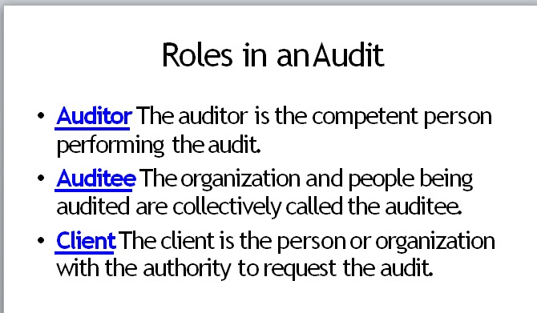

**Question 14 O out of 1 points**

When evaluating the collective effect of preventive. detective and corrective controls within a process, an IS auditor should be aware of which of the following

When evaluating the collective effect of preventive, detective, or corrective controls within a process, an IS auditor should be aware of the point at which controls are exercised as **data flows** through the system.

**Question 16** **3 out of 3 points**

What steps would an IS auditor perform to determine an organization's level of compliance with the laws and regulations? List any three steps.

1. Review and assessment of laws, regulations, and industry standards that apply to the organization. This step involves identifying all the applicable laws, regulations, and industry standards that the organization is subject to, and evaluating the organization's policies, procedures, and controls to ensure compliance with them.
2. Conducting internal audits and assessments. This step involves performing a thorough examination of the organization's systems, processes, and controls to identify any potential vulnerabilities or non-compliance issues. This may include conducting interviews with staff, reviewing documentation and records, and performing testing and validation of controls.
3. Reporting and monitoring. This step involves documenting the findings from the review and assessment, and any internal audits and assessments. A report is generated and provided to the organization's management. Any identified non-compliance issues or vulnerabilities must be tracked and monitored until they are resolved.

Ensure that effective processes exist for complying with applicable laws and regulations that affect IT and for maintaining awareness of changes in the regulatory environment.

* Could results in fines, lawsuits and damaged reputations.
* There should be a process for monitoring regulatory environment

How

* Look for the person responsible.
* Check the processes for evaluating the regulatory environment and evaluate their effectiveness.

**Question 18 1 out of 1 points**

How should the auditor assist in addressing problems found during the audit?

Sir/Madam, in my role as external auditor, I must remain independent of design decisions; otherwise, I would not be able to provide you the independence and objectivity required. Providing design advice would be a violation of several standards governing auditor independence,

**Question 19 1 out of 1 points** Who should issue the organizational policies?

Organizational policies should be issued by the management or leadership of the organization, such as the CEO, board of directors, or department heads. The process of creating and issuing policies should involve input and collaboration from relevant stakeholders within the organization, including employees and legal counsel. The goal is to ensure that the policies align with the organization's goals and values, and are legally compliant.

**Question 20 2 out of 6 points**

Please explain the difference between Standards, Guidelines and tools?

* **Standards** contain statements of mandatory requirements.
* **Guidelines** These are intended to provide advice pertaining to how organizational objectives might be obtained in the absence of a standard
* The tools and techniques documents provide information on how to meet the standards when performing IS auditing work but do not set requirements.
* **Tools and techniques** documents include:
  + White papers
  + Audit/Assurance programs
  + COBIT 5 family of products
  + Technical and Risk Management Reference series
  + ISACA Journal IT Audit Basics

**Question 21 O out of 1 points**

What is the term "auditor independence" related to?

**Auditor independence** refers to the independence of the internal auditor or of the external auditor from parties that may have a financial interest in the business being audited. Independence requires integrity and an objective approach to the audit process.